* Issues solution:

1. **contract Ownable is unused**: it is used now in PauseRole and MinterRole.
2. **function _burnFrom is public**: it has been set to internal. 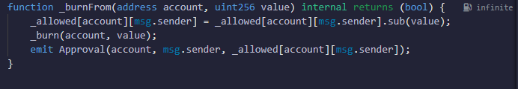
3. **Can still mint and burn tokens when paused**: it is fixed using whenNotPaused modifier:
   1. Mint: 
   2. Burn: 
4. **Missing removePauser**: it is addedGraphical user interface, text

   Description automatically generated

* Recommendation:

1. Added only owner can add or remove roles(minter, pauser):
   1. Pauser Role: Text

      Description automatically generated
   2. Minter Role: Text

      Description automatically generated
2. onlyMinter() fix: Text

   Description automatically generated